skene medical group 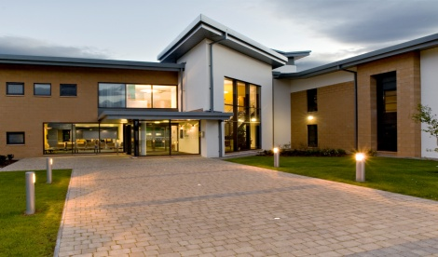

**Short term locum ANP/GP**

Due to planned short term absence of one of our ANPs, we are looking for a locum ANP or GP commencing 21/07/2025.

Skene is a supportive, friendly and well managed practice with over 15,000 patients. Our ethos not only puts high quality multidisciplinary patient care at its centre but also prides itself in maintaining a cohesive and supportive team approach. Our Partner led Vision based practice is welcoming, forward thinking and proud to provide primary care from a purpose-built surgery situated 7 miles west of Aberdeen.

* Modern attractive, purpose-built premises including a staff gym. Easy access to the practice via AWPR.
* 12 appointments per routine session (a combination of face to face and telephone appointments)
* Duty team consisting of two GPs and ANP working together
* Low home visit numbers
* Robust multidisciplinary team comprising GPs, ANPs, pharmacotherapy team, physiotherapy, GPwSI dermatology, practice nurses, district nurses, health visitors. All co-located in same building making team working and communication easier.
* Excellent management and administrative staff
* Strong educational ethos. Undergraduate teaching and training practice for GP trainees.
* Specialist clinics: diabetes, coils, implants, minor surgery, joint injections, dermatology.

The successful candidate must have excellent clinical, communication, interpersonal and organisational skills.

Practice information can be found at [www.skenemedicalgroup.co.uk](http://www.skenemedicalgroup.co.uk), informal enquiries can be sent to [gram.skeneadministrator@nhs.scot](mailto:gram.skeneadministrator@nhs.scot)

To apply please send your CV along with a covering letter explaining what attracts you to this post and giving reasons why you consider yourself to be a suitable candidate to: [gram.skeneadministrator@nhs.scot](mailto:gram.skeneadministrator@nhs.scot)